

|  |  |  |  |  |
| --- | --- | --- | --- | --- |
| Year 12 Physics – Test 2 (Task 2)  **Gravity and Motion** | | | | |
|  | | | | |
| Name: | | | | |
| **Time allowed**: 50 minutes + 5 mins reading time (at discretion of teacher) | | | | |
| **Section** | Number of questions | Your Mark | Marks available | Percentage of Test |
| **Section One:**  Short answer | 4 |  | 13 | 30 |
| **Section Two**:  Extended answer | 3 |  | 22 | 50 |
| **Section Three:**  Comprehension  and data analysis | 1 |  | 12 | 20 |
|  | **Total** |  | **47** | **100** |

* Final answers should be given up to three significant figures and include appropriate units where appropriate. Questions containing the instruction "ESTIMATE" should be given two significant figures and include appropriate units where applicable.
* Scientific Calculators are allowed.
* No notes allowed.
* Formula sheet is provided.

**Section One:** Short answer

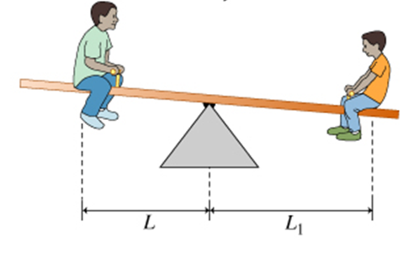

1. **(3 marks)**

A small boy and his older brother are using a see-saw with adjustable seating positions, as shown.

If the smaller boy has a mass of 20.0kg and is 2.20m from the pivot, what is the larger boys mass if he is sitting 1.10 m from the pivot? You may assume the see-saw is horizontal

Answer ____________________________________ kg

1. **(4 marks)**

The diagrams below show designs for two vases. The centre of mass, G, is marked on each.

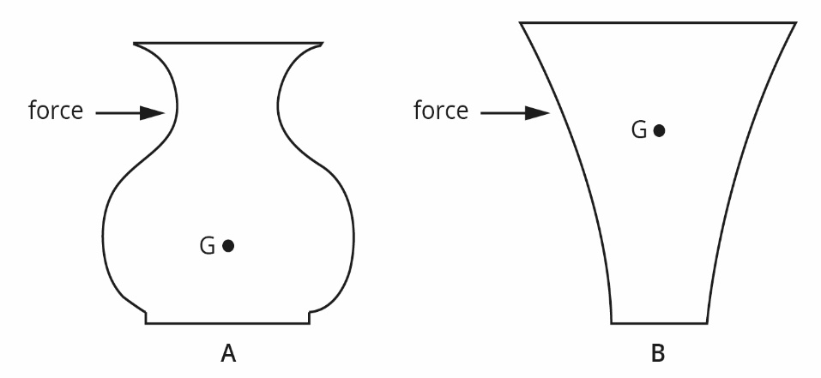

State which of the two vases is more stable and therefore least likely to be tipped over. Using the diagrams and appropriate physics principles, explain your answer.

1. **(4 marks)**

Astronauts in training for weightlessness are given some practice in a plane, which flies in vertical loop of radius 600 m at such a speed that at the top of the path they feel “weightless”. At what speed must the plane be flying to achieve this effect? Carefully explain your logic using appropriate equations or vector diagrams.

Answer $ms^{-1}$

____________________________________

1. **(2 marks)**

A researcher measured the strength of the gravitational field (*g*) of an object of mass (*m*) at a range of distances (*r*) from the object and plotted the inverse of the square of the distance from the object against gravitational field strength. The graph below shows the plot.

Describe what the shape of the graph indicates about the relationship between gravitational field strength and distance from the object.

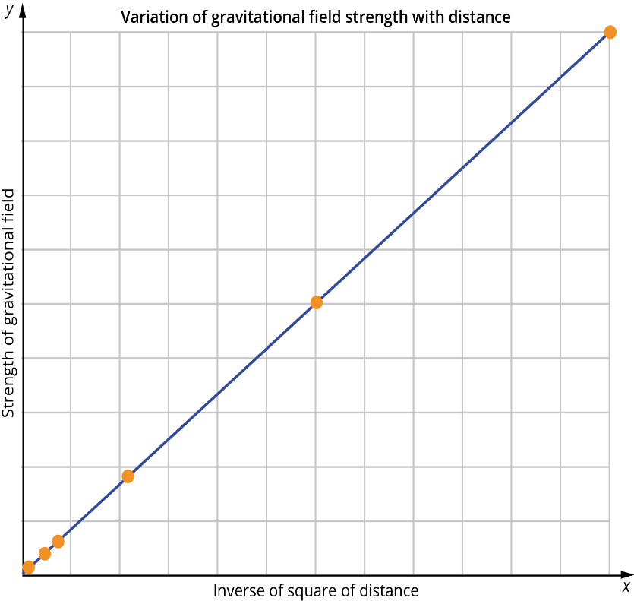

**Section Two:** Extended answer

1. **(8 marks)**

Sharon is playing on a swing which is supported by two 2.60m long cables. The combine mass of Sharron and the swing is 39.4 kg.

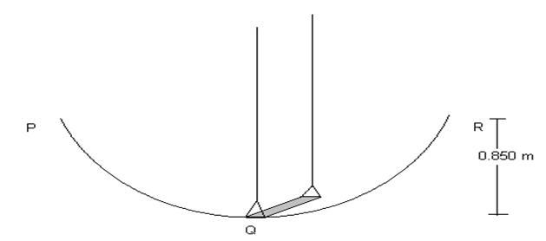

She is able to swing to a height of 0.850 m (points P and R) above the lowest point of the swing (point Q).

1. At which point in the swing will Sharon have the greatest velocity and what is her velocity at that point?

(3 Marks)

Answer $ms^{-1}$

____________________________________

1. The tension in the two cables will vary as the swing moves through its arc. What will be the maximum tension in each cable?

(5 marks)

Answer ____________________________________ N

1. **(9 marks)**

A 75 kg sign is suspended from a uniform 8.5 kg wooden beam of length 2.2 m. The sign is 1.8 m from the wall and a steel cable is attached to the beam 1.5 m from the wall at an angle of 45°.

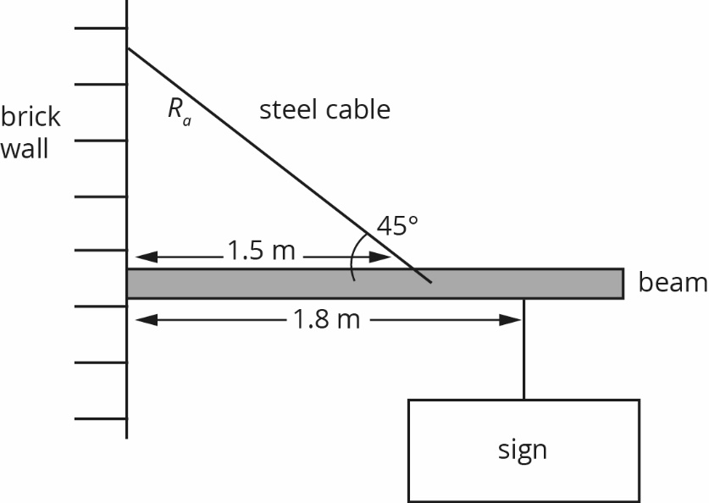

1. Determine the tension in the steel cable.

(5 marks)

Answer ____________________________________ N

1. Determine the size and direction of the force supplied by the brick wall on the beam.

(4 marks)

Answer ____________________________________ N Direction ________________________________

1. **(5 marks)**

Ben, whose total mass is 1.20 x 102 kg (Ben and space suit) is on a spacewalk 725 km above the Earth. Assuming that the force of the nearby space ship is insignificant compared to the force of the Earth,

1. What gravitational acceleration does Ben experience on his spacewalk?

(3 marks)

Answer $ms^{-2}$

____________________________________

1. What gravitational force is on Ben?

(2 marks)

Answer ____________________________________ N

**Section Three:** Comprehension and data analysis

1. **(12 marks)**

In 10 years Global Positioning System [GPS] has gone from the USA military to being navigator tools to being a normal feature in many luxury cars today. They work by transmitting a beam of electro-magnetic radiation from an aerial on your car roof to one of 24 satellites surrounding the Earth. The reflected beam is received also by an aerial on your roof and your location on the ground can be determined to 50 m. In military application the resolution is less than 10 cm.

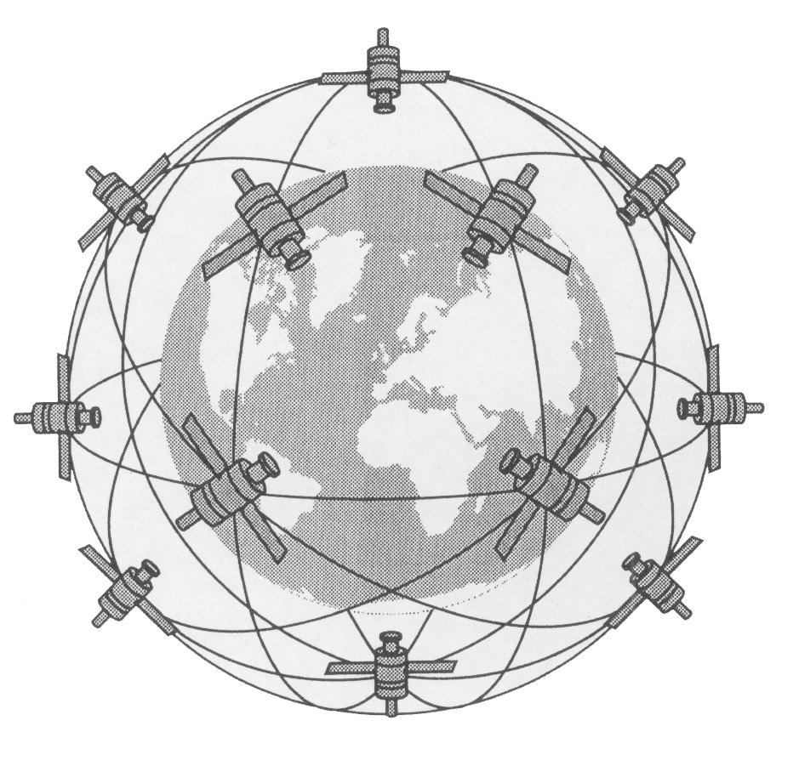

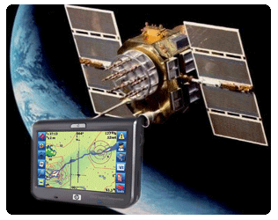

1. If the height of any one of these satellites is 17 800 km, what is the time for 1 orbit?

(4 marks)

Answer ____________________________________ s

1. Calculate how far such a satellite will travel in 10 mins.

(3 marks)

Answer ____________________________________ m

1. Determine the strength of Earth’s gravitational field at this orbiting height.

(2 marks)

Answer $Nkg^{-1}$

____________________________________

1. Carefully explain why satellites can only be in geostationary orbit around the equator. Use vector diagrams to support your answer

(3 marks)

E**nd of Test**